Vpc2= virtual private cloud task=2
- Create one VPC, with 1 public subnet and 1 private subnet.
Create your vpc
Name-
Ipv4 CIDR-
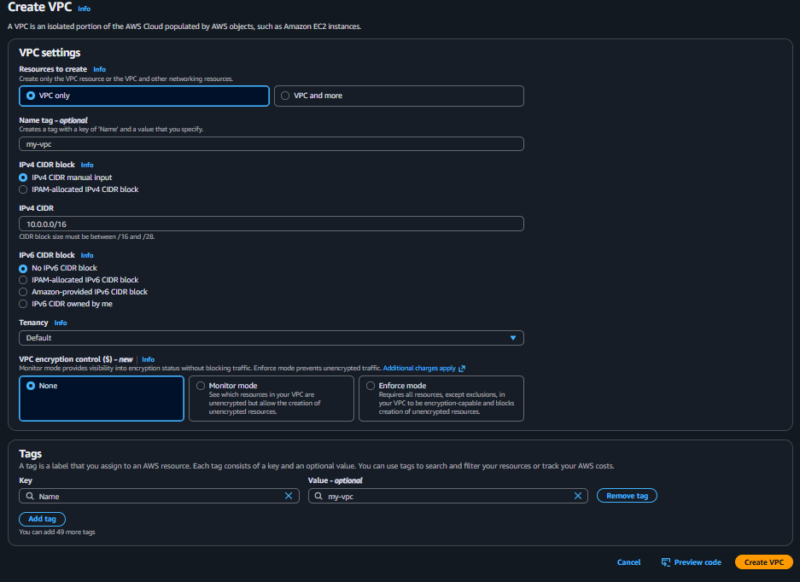

Create 1 Public Subnet + 1 Private Subnet
With same steps just change it name and ipv4 CIDR

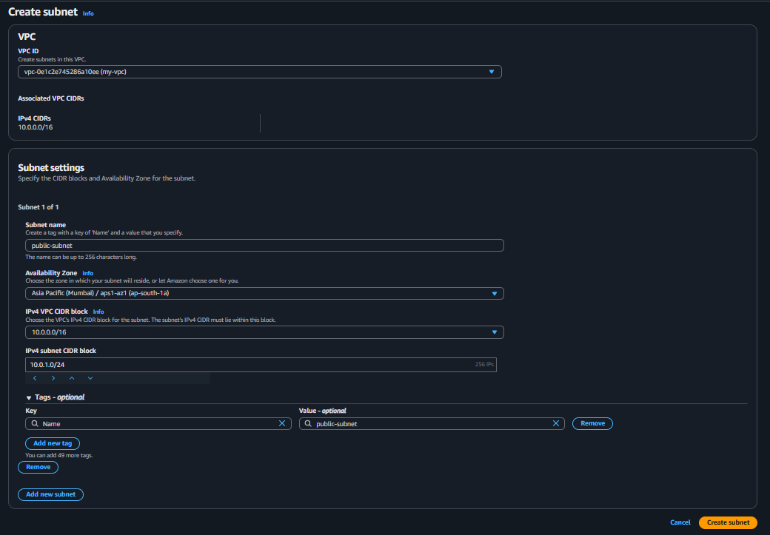

Ok now we public and private subnets
1 public
1 private

2. Enable VPC peering for cross-region.
Create one more vpc make sure change region
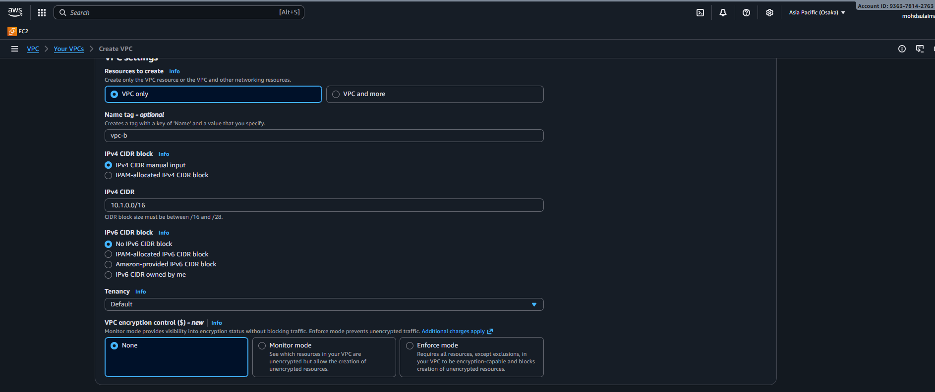
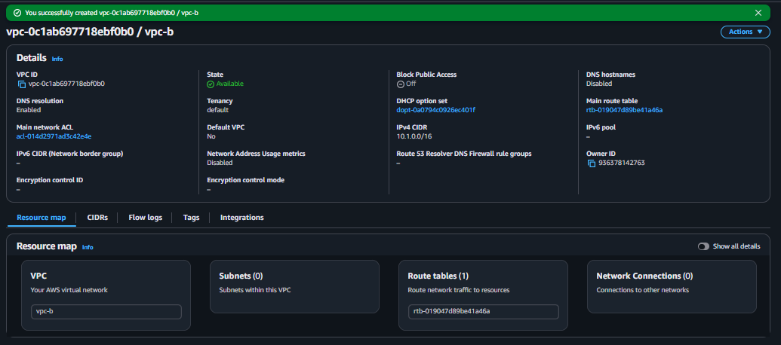
- Now create peering connection

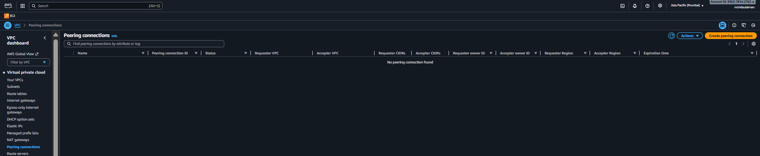

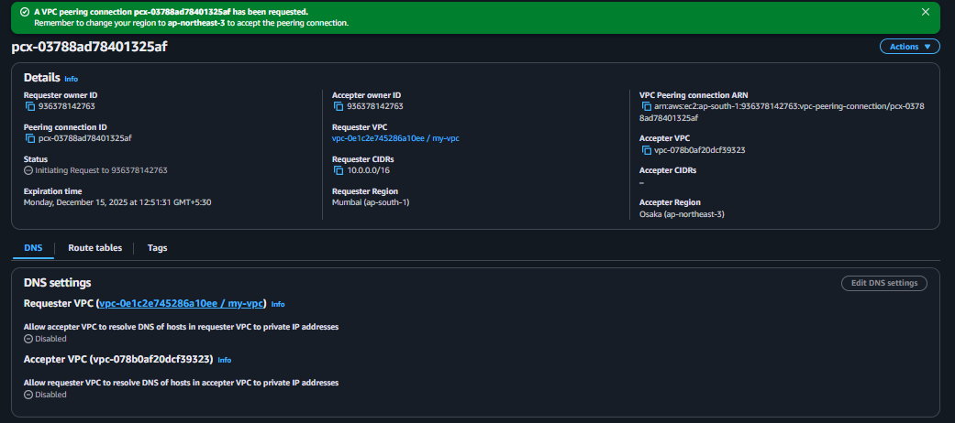

Now we getting request from another vpc which is in osaka
Now we accept the request
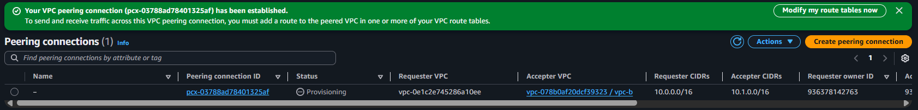
3. Enable VPC peering for cross-account
Now create peering connection

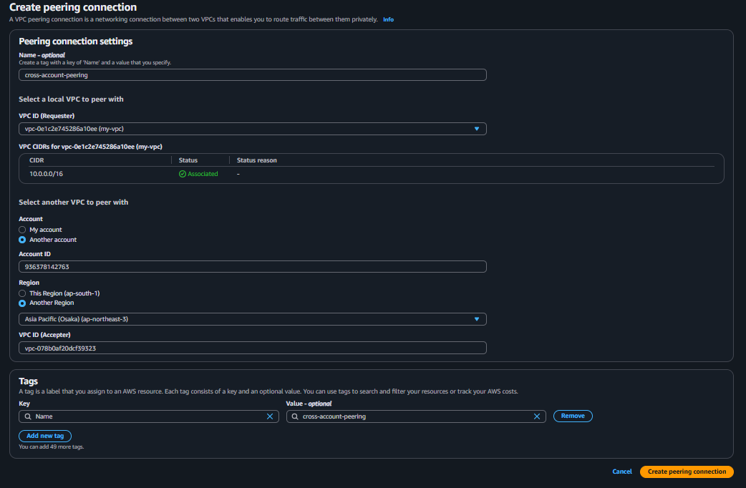
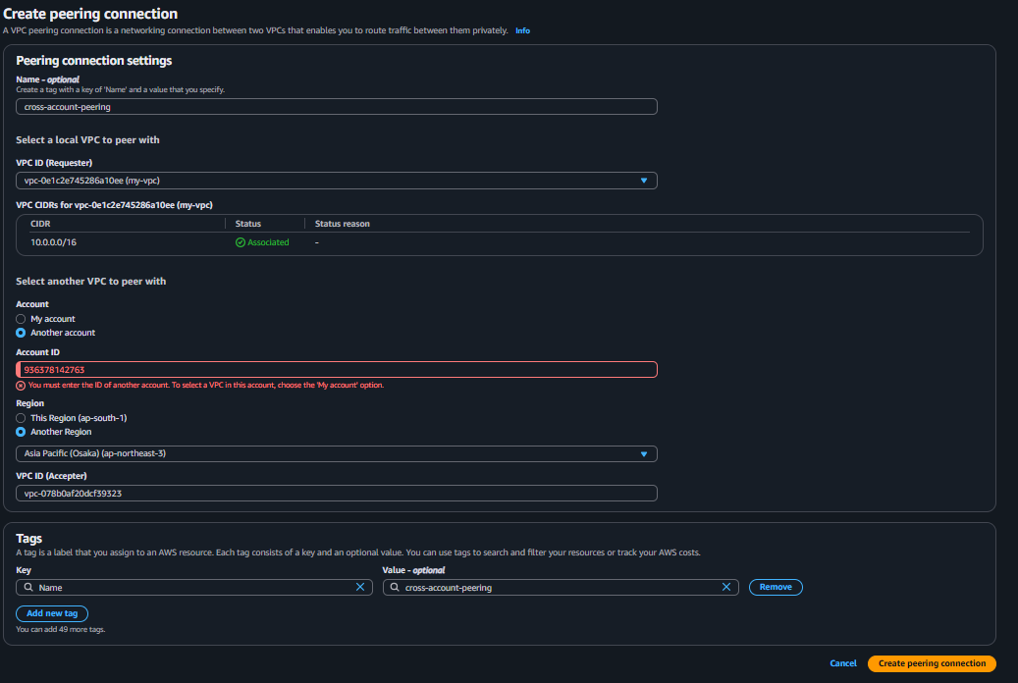
At this time I don’t any friend account if we have do same steps but in place of account id you need write your friend account id
IF FRIEND ACCEPTS THE REQUEST IT SAY
Your friend logs in to their AWS account → VPC → Peering → they will see
pcx-xxxxxxx
Status: Pending acceptance
Requester: Your account ID
Actions → Accept request
Status becomes: ACTIVE
By this steps create perring connection from one destination to another destination

4. Set up a VPC Transit Gateway.
- First create you transit gateway

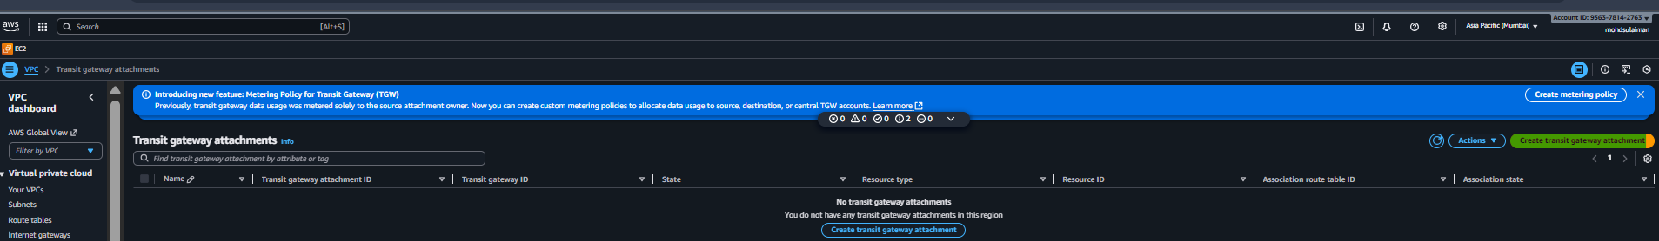

- Create your transit gateway 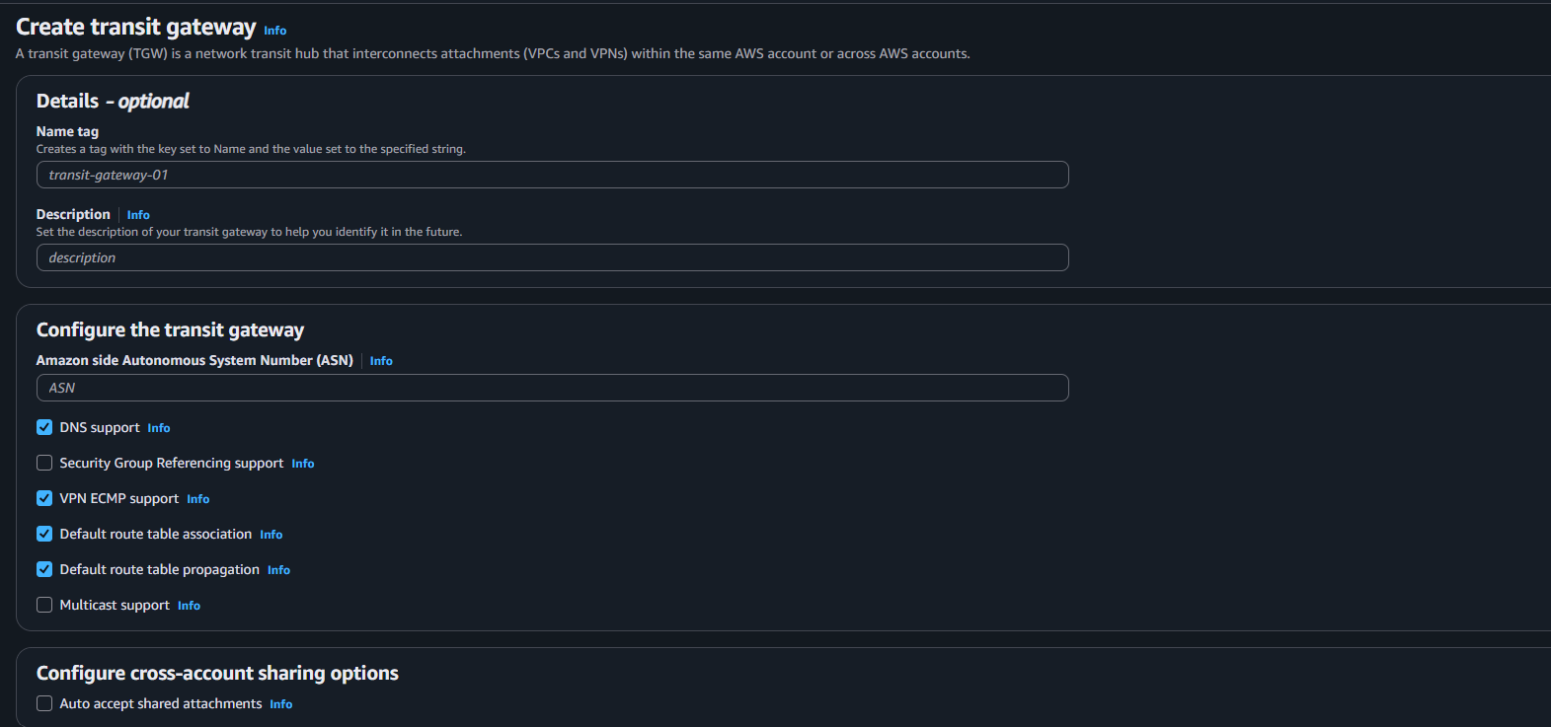

- Now attach your tansit gateway that create
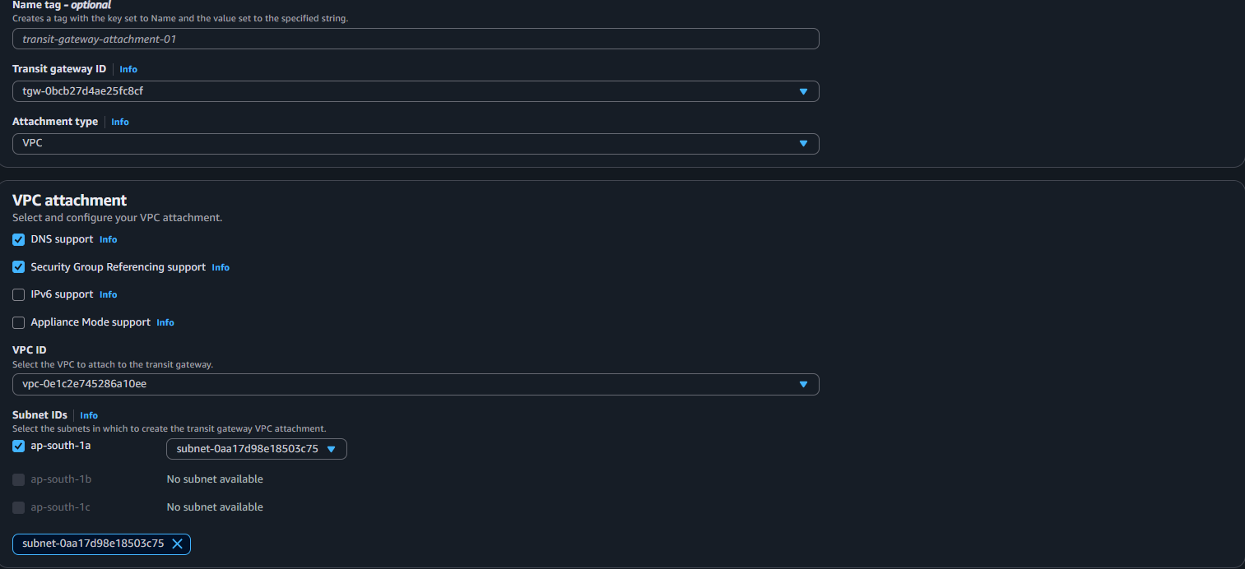
- Now edit routes and click on save changes
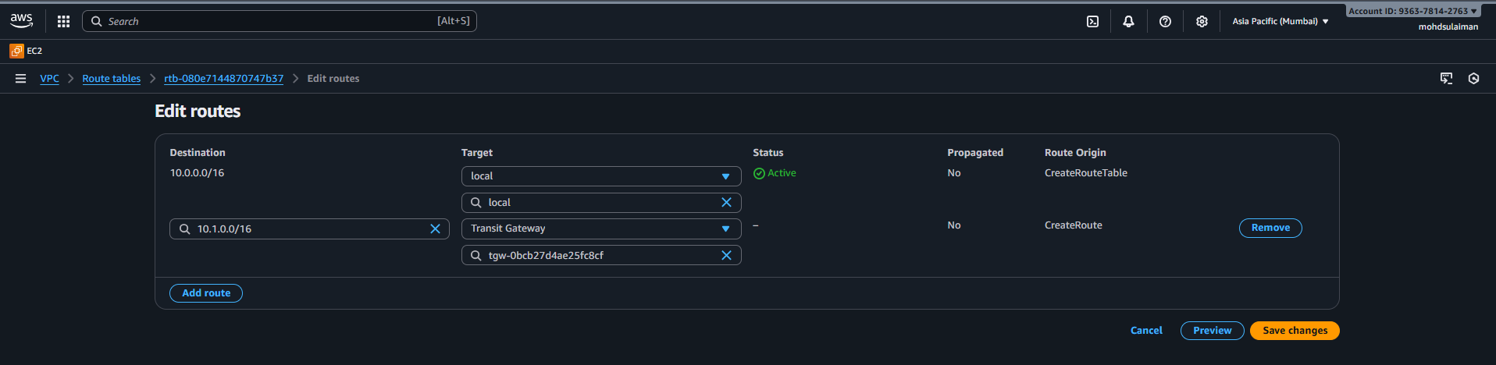
5 Set up a VPC Endpoint
Create your vpc endpoint
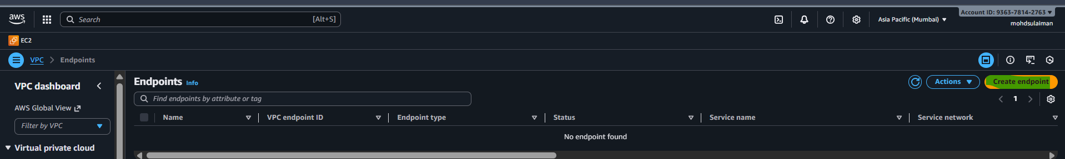
- Now give name tag
- Also gives your vpc
- Then select your subnet
- Ipv4 or ipv6
- That it now click on create endpoint 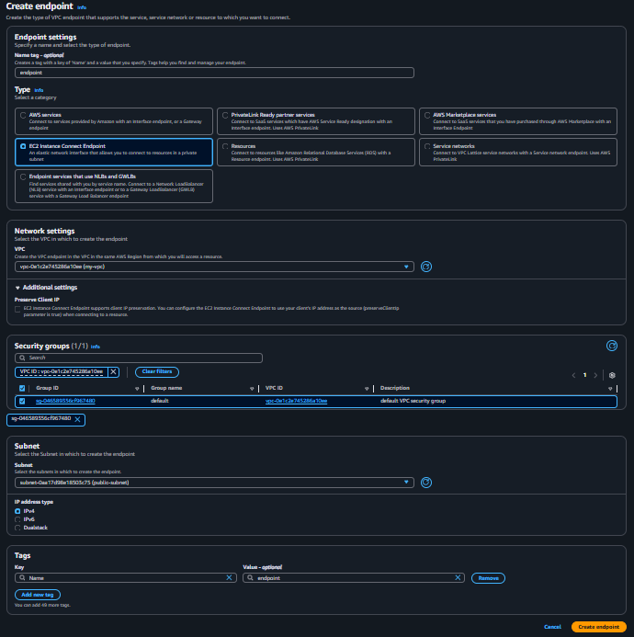

Now we succefully create our endpoint
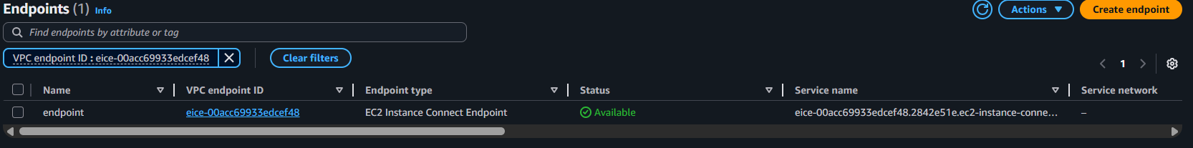
Thanks for reviving my Task

